**Stage 2 - March comes in like a lamb and goes out like a lion**

**RULES:** USPSA Competition Rules, Latest Edition **COURSE DESIGNER:** Ike Starnes

|  |  |
| --- | --- |
| **START POSITION:** Both feet on the Shooting Sports Innovation Xs, palms flat on table.  **Firearm**: Unloaded and unpropped on table, trigger guard over mark  **All mags to be used must be placed on the table prior to the start signal.** | |
| **STAGE PROCEDURE**  See written stage briefing. | **SCORING**  **SCORING:** Comstock 28 rounds.  **TARGETS:** 14 cardboard targets  **SCORED HITS:** 2 Best hits per carboard will be scored.  **START-STOP:**  Audible - Last shot  **PENALTIES:** Per USPSA Competition Rules |

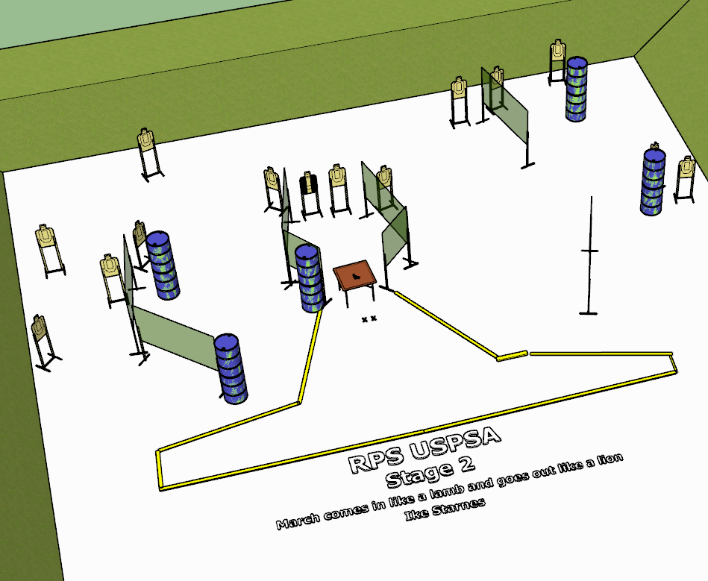

**Written Stage Briefing:**

**Stage 2 - March comes in like a lamb and goes out like a lion -** is a 28-round, 140 point, Comstock Long Course. There are 14 cardboard targets. The best 2 hits per cardboard target will be scored.

**Start position** Both feet on the Shooting Sports Innovation Xs, palms flat on table.

**Firearm**: Unloaded and unpropped on table, trigger guard over mark.

**All mags to be used must be placed on the table prior to the start signal.**

On the audible start signal, engage targets from within the shooting area.

**USPSA / NROI Range Commands:**

* Make Ready
* Are you ready?
* Standby
* If finished, unload and show clear.
* If clear, hammer down and holster
* Range is clear

**Setup Notes:**

16 Single Wall Stands

2 Double Wall Stands

6 Full Walls

2 Ported Walls

2 Half Walls

14 Target stands

28 Target Sticks

2 Shooting Sports Innovations Starting Xs

16+ Barrels

**Be mindful of the target placement, try to avoid shots hitting the posts.**